P4b JavaScript Revision

# Repository link:

[<https://github.com/alisonvpereira/P4b-Revising-JS>](https://github.com/alisonvpereira/P3-She-Codes-News)

# Exercise 1

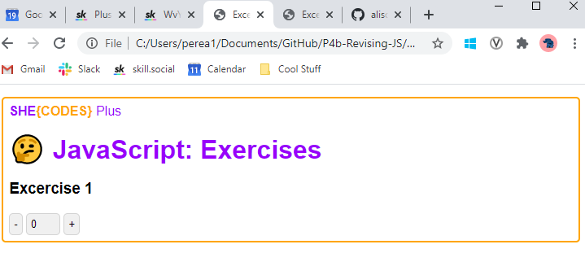

# Exercise 2

